BANK LOAN REPORT — SQL QUERY DOCUMENT
Made by Siddu Varikuppala
LinkedIn: https://in.linkedin.com/in/siddu-data

SUMMARY
Total Loan Applications
SELECT COUNT(id) AS Total_Applications FROM bank_loan_data
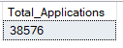
MTD Loan Applications
SELECT COUNT(id) AS Total_Applications FROM bank_loan_data
WHERE MONTH(issue_date) = 12
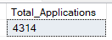
PMTD Loan Applications
SELECT COUNT(id) AS Total_Applications FROM bank_loan_data
WHERE MONTH(issue_date) = 11
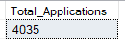
Total Funded Amount
SELECT SUM(loan_amount) AS Total_Funded_Amount FROM bank_loan_data
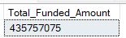
MTD Total Funded Amount
SELECT SUM(loan_amount) AS Total_Funded_Amount FROM bank_loan_data
WHERE MONTH(issue_date) = 12
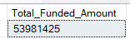
PMTD Total Funded Amount
SELECT SUM(loan_amount) AS Total_Funded_Amount FROM bank_loan_data
WHERE MONTH(issue_date) = 11
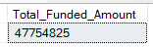
Total Amount Received
SELECT SUM(total_payment) AS Total_Amount_Collected FROM bank_loan_data
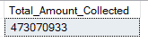
MTD Total Amount Received
SELECT SUM(total_payment) AS Total_Amount_Collected FROM bank_loan_data
WHERE MONTH(issue_date) = 12
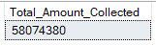
PMTD Total Amount Received
SELECT SUM(total_payment) AS Total_Amount_Collected FROM bank_loan_data
WHERE MONTH(issue_date) = 11
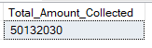
Average Interest Rate
SELECT AVG(int_rate)*100 AS Avg_Int_Rate FROM bank_loan_data
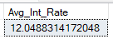
MTD Average Interest
SELECT AVG(int_rate)*100 AS MTD_Avg_Int_Rate FROM bank_loan_data
WHERE MONTH(issue_date) = 12
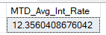
PMTD Average Interest
SELECT AVG(int_rate)*100 AS PMTD_Avg_Int_Rate FROM bank_loan_data
WHERE MONTH(issue_date) = 11
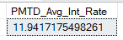
Avg DTI
SELECT AVG(dti)*100 AS Avg_DTI FROM bank_loan_data
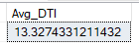
MTD Avg DTI
SELECT AVG(dti)*100 AS MTD_Avg_DTI FROM bank_loan_data
WHERE MONTH(issue_date) = 12
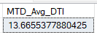
PMTD Avg DTI
SELECT AVG(dti)*100 AS PMTD_Avg_DTI FROM bank_loan_data
WHERE MONTH(issue_date) = 11
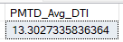

GOOD LOAN ISSUED
Good Loan Percentage
SELECT
(COUNT(CASE WHEN loan_status = 'Fully Paid' OR loan_status = 'Current' THEN id END) * 100.0) /
COUNT(id) AS Good_Loan_Percentage
FROM bank_loan_data
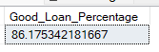
Good Loan Applications
SELECT COUNT(id) AS Good_Loan_Applications FROM bank_loan_data
WHERE loan_status = 'Fully Paid' OR loan_status = 'Current'
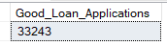
Good Loan Funded Amount
SELECT SUM(loan_amount) AS Good_Loan_Funded_amount FROM bank_loan_data
WHERE loan_status = 'Fully Paid' OR loan_status = 'Current'
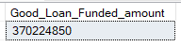
Good Loan Amount Received
SELECT SUM(total_payment) AS Good_Loan_amount_received FROM bank_loan_data
WHERE loan_status = 'Fully Paid' OR loan_status = 'Current'
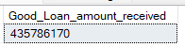

BAD LOAN ISSUED
Bad Loan Percentage
SELECT
(COUNT(CASE WHEN loan_status = 'Charged Off' THEN id END) * 100.0) /
COUNT(id) AS Bad_Loan_Percentage
FROM bank_loan_data
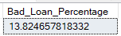
Bad Loan Applications
SELECT COUNT(id) AS Bad_Loan_Applications FROM bank_loan_data
WHERE loan_status = 'Charged Off'
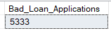
Bad Loan Funded Amount
SELECT SUM(loan_amount) AS Bad_Loan_Funded_amount FROM bank_loan_data
WHERE loan_status = 'Charged Off'
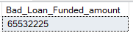
Bad Loan Amount Received
SELECT SUM(total_payment) AS Bad_Loan_amount_received FROM bank_loan_data
WHERE loan_status = 'Charged Off'
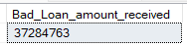

LOAN STATUS
Loan Status Summary
SELECT
loan_status,
COUNT(id) AS LoanCount,
SUM(total_payment) AS Total_Amount_Received,
SUM(loan_amount) AS Total_Funded_Amount,
AVG(int_rate * 100) AS Interest_Rate,
AVG(dti * 100) AS DTI
FROM bank_loan_data
GROUP BY loan_status
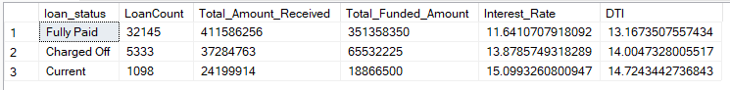
Loan Status - MTD
SELECT
loan_status,
SUM(total_payment) AS MTD_Total_Amount_Received,
SUM(loan_amount) AS MTD_Total_Funded_Amount
FROM bank_loan_data
WHERE MONTH(issue_date) = 12
GROUP BY loan_status
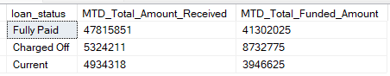

OVERVIEW
Month
SELECT
MONTH(issue_date) AS Month_Number,
DATENAME(MONTH, issue_date) AS Month_name,
COUNT(id) AS Total_Loan_Applications,
SUM(loan_amount) AS Total_Funded_Amount,
SUM(total_payment) AS Total_Amount_Received
FROM bank_loan_data
GROUP BY MONTH(issue_date), DATENAME(MONTH, issue_date)
ORDER BY MONTH(issue_date)
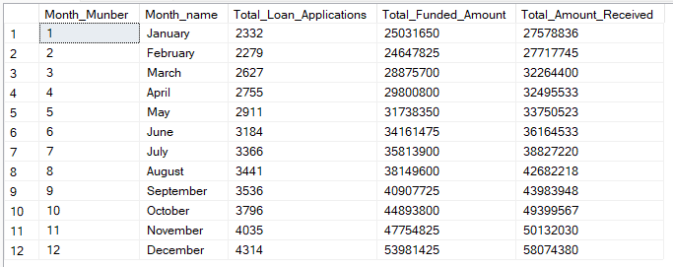
State
SELECT
address_state AS State,
COUNT(id) AS Total_Loan_Applications,
SUM(loan_amount) AS Total_Funded_Amount,
SUM(total_payment) AS Total_Amount_Received
FROM bank_loan_data
GROUP BY address_state
ORDER BY address_state
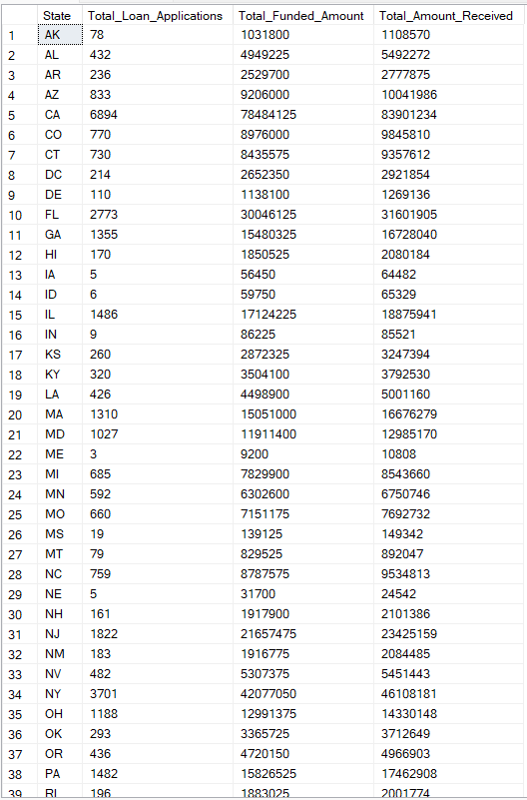
Term
SELECT
term AS Term,
COUNT(id) AS Total_Loan_Applications,
SUM(loan_amount) AS Total_Funded_Amount,
SUM(total_payment) AS Total_Amount_Received
FROM bank_loan_data
GROUP BY term
ORDER BY term
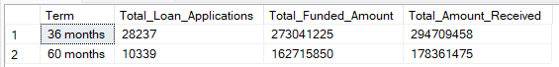
Employee Length
SELECT
emp_length AS Employee_Length,
COUNT(id) AS Total_Loan_Applications,
SUM(loan_amount) AS Total_Funded_Amount,
SUM(total_payment) AS Total_Amount_Received
FROM bank_loan_data
GROUP BY emp_length
ORDER BY emp_length
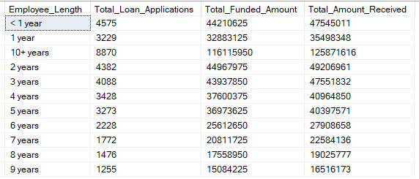
Purpose
SELECT
purpose AS PURPOSE,
COUNT(id) AS Total_Loan_Applications,
SUM(loan_amount) AS Total_Funded_Amount,
SUM(total_payment) AS Total_Amount_Received
FROM bank_loan_data
GROUP BY purpose
ORDER BY purpose
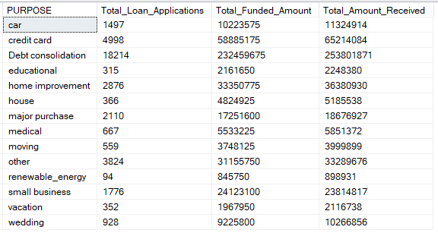
Home Ownership
SELECT
home_ownership AS Home_Ownership,
COUNT(id) AS Total_Loan_Applications,
SUM(loan_amount) AS Total_Funded_Amount,
SUM(total_payment) AS Total_Amount_Received
FROM bank_loan_data
GROUP BY home_ownership
ORDER BY home_ownership
